**TY B.Tech. (CSE) – II [2022-23]**

**5CS372: Advanced Database System Lab.**

**Assignment No. 1**

**Name : Tanaya Mukund Bhide**

**PRN : 2020BTECS00011**

**Batch : T5**

**Branch: T.Y CSE**

**I. PL / SQL Review:**

**Objective** :

To refresh and improve understanding of PL/SQL syntax and implementation.

**Introduction**:

PL/SQL is Oracle Corporation's procedural extension for SQL and the Oracle relational database. PL/SQL is available in Oracle Database, as well as Oracle's Times Ten in-memory database.

**Theory** :

PL/SQL is a procedural language designed for use with Oracle Database management system. It is used to create programs that are executed within the database environment. PL/SQL programs can be used to perform various operations on the database, such as querying, inserting, updating, and deleting data.

PL/SQL is an extension of SQL, the standard language for interacting with relational databases. In addition to the SQL statements, PL/SQL provides additional procedural constructs such as variables, loops, conditional statements, and exception handling. These constructs enable developers to write complex programs that can perform multiple operations on the database.

PL/SQL programs can be stored and executed within the database as stored procedures, functions, triggers, and packages. Stored procedures are named blocks of code that can be called by other programs or users. Functions are similar to procedures but return a single value. Triggers are special procedures that are executed automatically in response to certain events, such as a data insert, update, or delete operation. Packages are collections of related procedures, functions, variables, and other program objects that can be shared among multiple PL/SQL programs.

PL/SQL programs are compiled and executed within the database environment, which provides several advantages over other programming languages. First, PL/SQL programs can take advantage of the database server's processing power and memory resources. Second, PL/SQL programs can reduce network traffic and improve performance by executing multiple SQL statements within a single program. Finally, PL/SQL programs can be secured using Oracle's built-in security features, such as roles and privileges.

Overall, PL/SQL is a powerful and flexible language that is essential for developing complex database applications that require a high degree of performance, security, and reliability.

a) Create a table called test_table with 2 columns RecordNumber (type: Number(3)) and CurrentDate (type: Date)). Write PL/SQL block which will insert 50 records into test_table. Insert the current date value into the table.

we first create the test_table with the RecordNumber and CurrentDate columns. Then, we declare a variable currentDate and initialize it to the current date using the SYSDATE function. 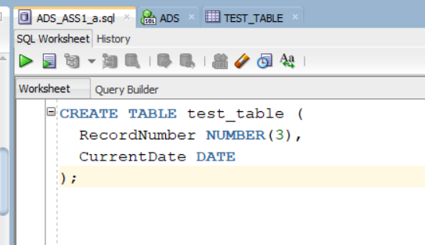

Table TEST_TABLE created :

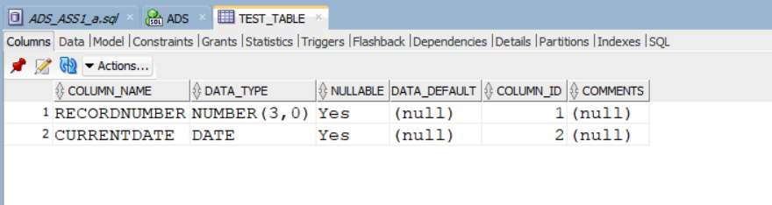

we use a FOR loop to iterate from 1 to 50, and for each iteration, we insert a record into the test_table with the current value of i for RecordNumber and currentDate for CurrentDate. Finally, we commit the changes to the database using the COMMIT statement.

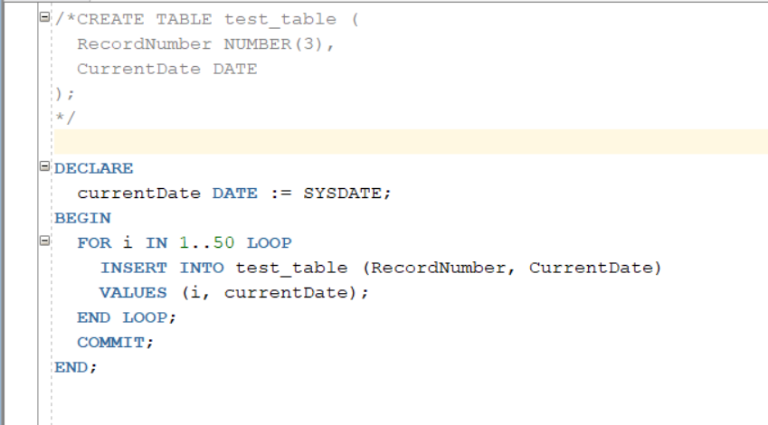

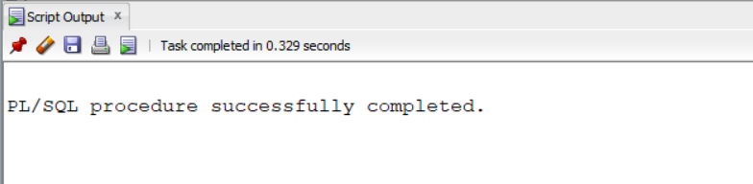

Output:

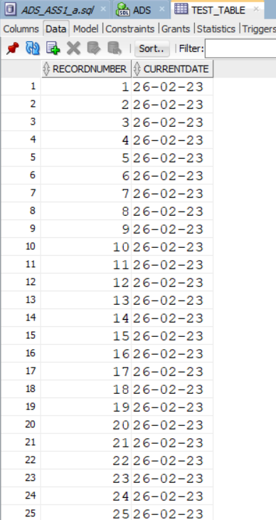

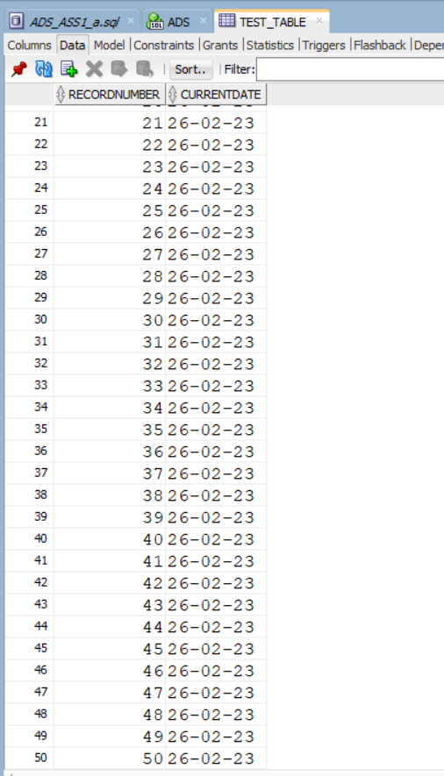

b) Create a products table products(ProductID number(4),category char(3),detail varchar2(30),price number(10,2),stock number(5)). Insert the sample data. Write PL/SQL procedure with two arguments X & Y which will increase the price by X% for all products in category Y. X and Y will be given by the user.

1.Creation of the Table

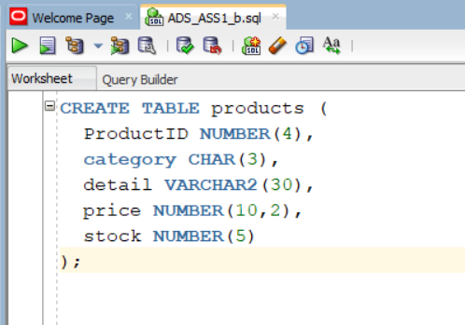 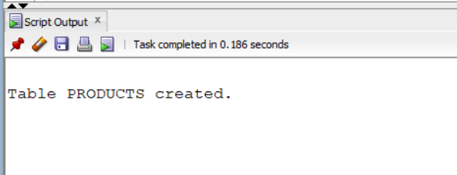 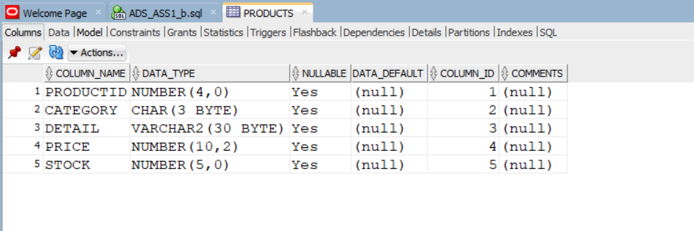

2.Insertion of the Data

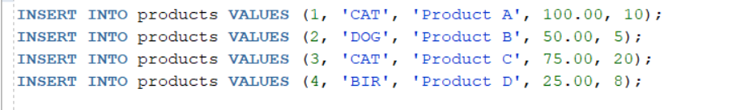

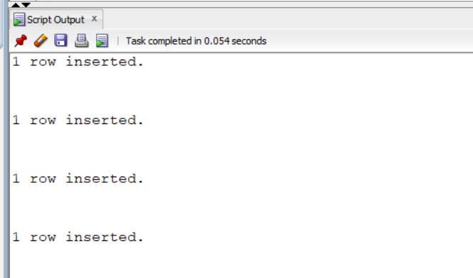

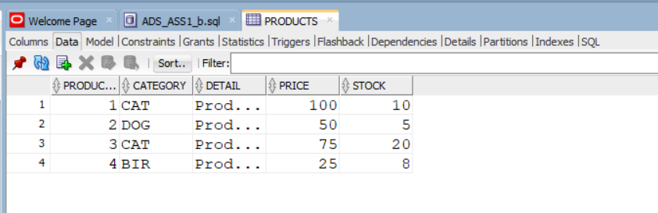

3. Write PL/SQL procedure with two arguments X & Y which will increase the price by X% for all products in category Y. X and Y will be given by the user.

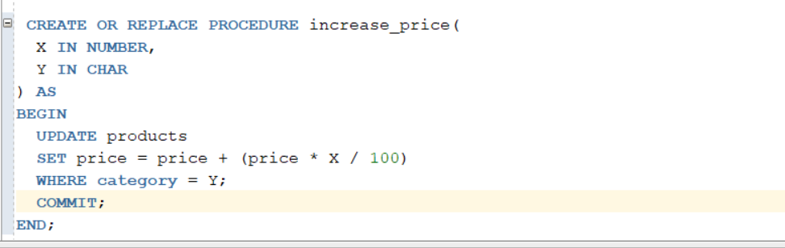

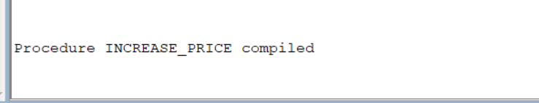

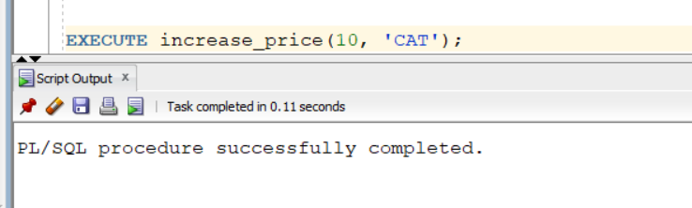

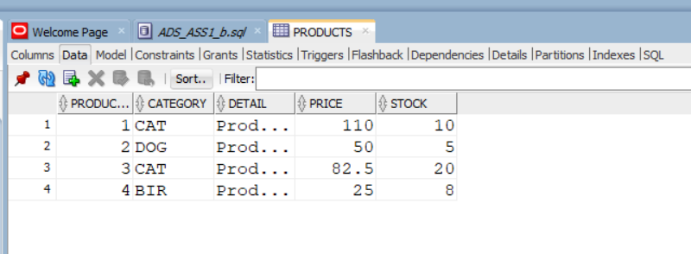

**II. Object Relational Databases:**

**Objective:**

To study Object-Relational Database Management Systems (ORDBMS) and their implementation

**Introduction :**

An object-relational database (ORD) is a database management system (DBMS) that's composed of both a relational database (RDBMS) and an object-oriented database (OODBMS). ORD supports the basic components of any object-oriented database model in its schemas and the query language used, such as objects, classes, and inheritance.

**Theory :**

The Object-Role Modeling (ORM) Data Modeling technique, also known as the ORD (Object-Role Modeling Diagrams) theory, is a conceptual modeling approach used to describe and analyze information and business processes in organizations. ORM is a graphical modeling language that can be used to represent complex relationships between objects, events, and processes in a structured and intuitive way.

The ORM approach emphasizes the importance of identifying and defining the key objects and roles in a domain, along with the relationships between them. Objects are the fundamental entities in a domain, and roles represent the behavior of these objects in relationships with other objects. Relationships are expressed as associations between roles, and these associations can be defined as mandatory or optional, and as having one or many instances.

ORD theory is a powerful tool for modeling complex business processes and data structures, and it is widely used in software development, data modeling, and database design. The graphical notation used in ORM diagrams is intuitive and easy to understand, which makes it a useful tool for communicating complex ideas and concepts to stakeholders in an organization.

1. Object Relational Databases: a) Create an Object Table containing the field “name” of size 50 characters and member function “countNoOfWords” which returns the no. of words in the “name” field. Demonstrate the working by entering different data.

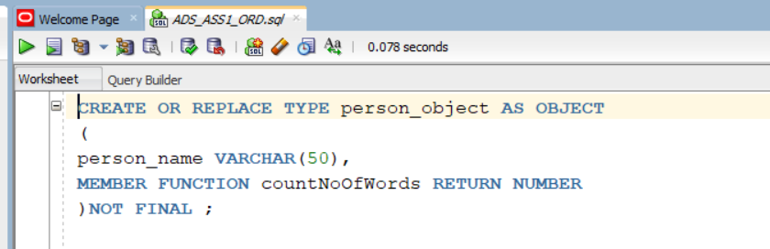 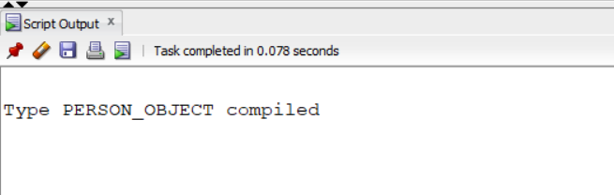 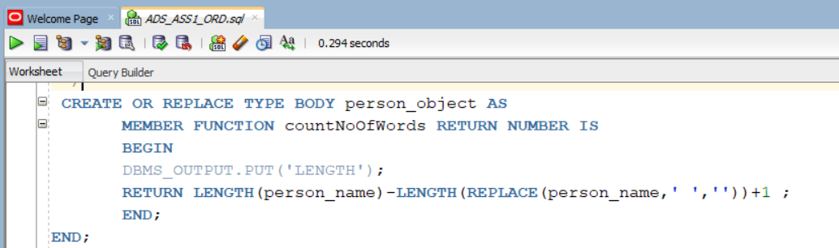 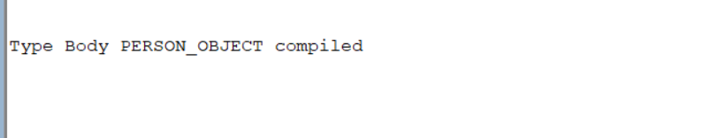

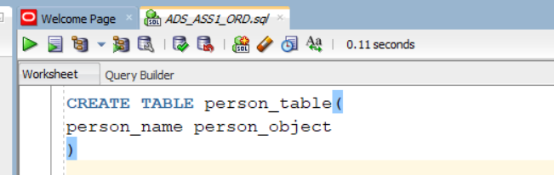

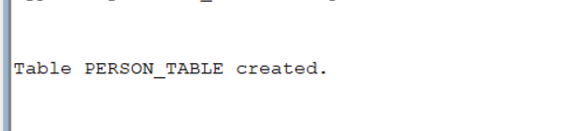

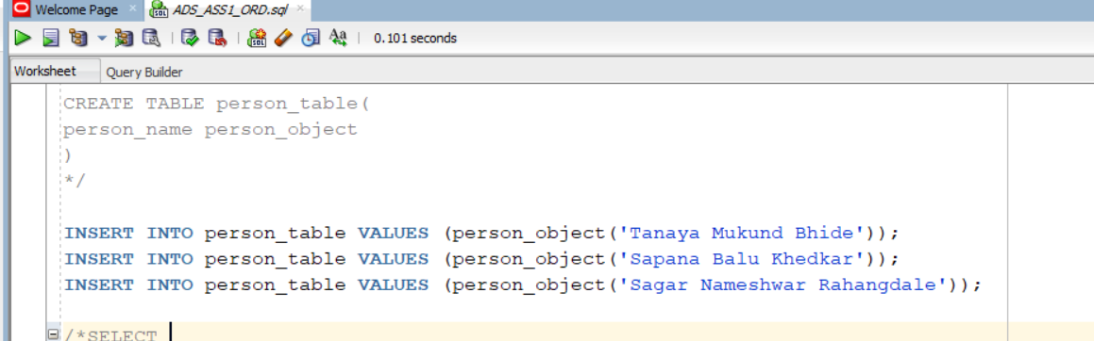 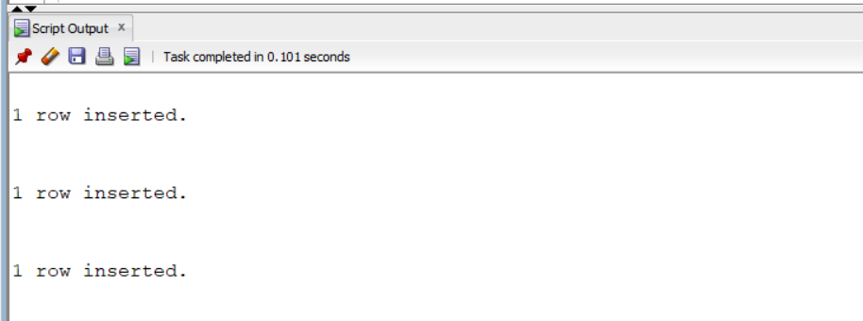

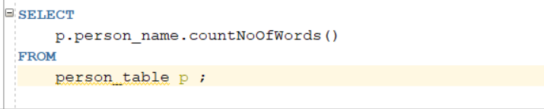 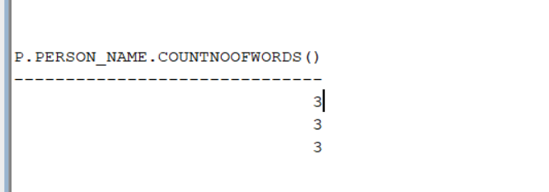

b) Create an address type with the following attributes: address, city, state & pin code. Include the following methods

i. to extract the addresses based on a given keyword.

j. to return the no. of words in each given field (method should accept the name of attribute/field).

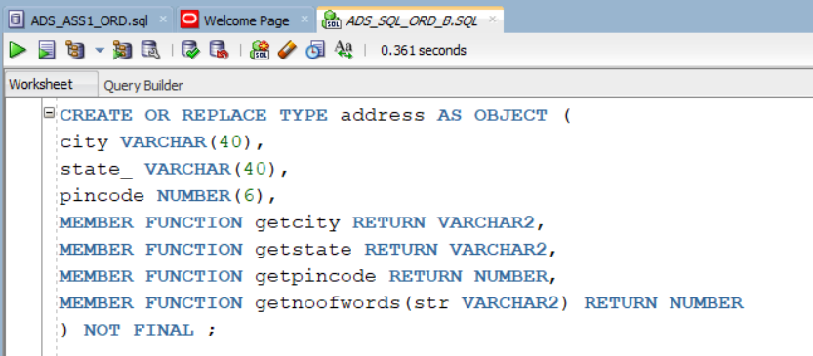

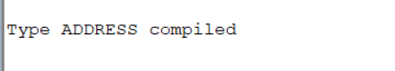

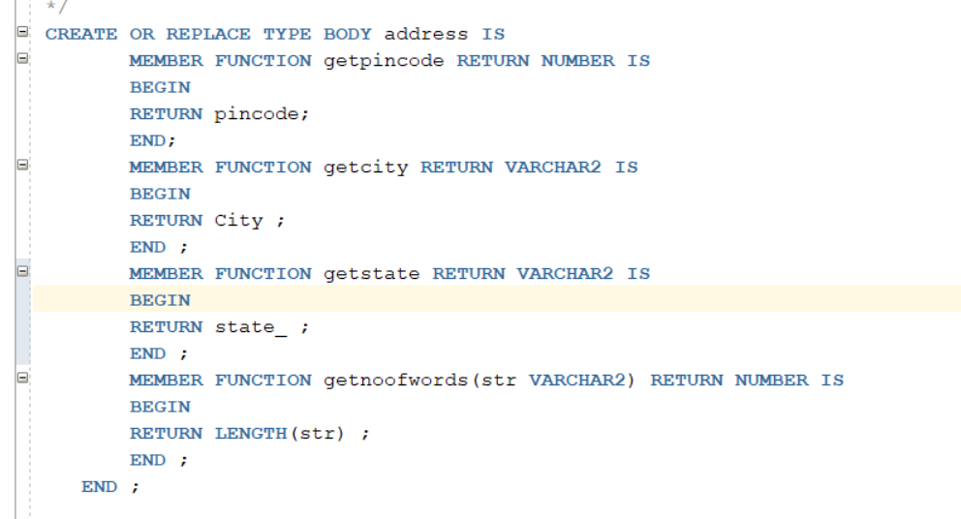

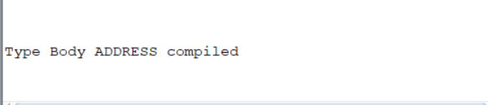

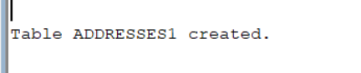



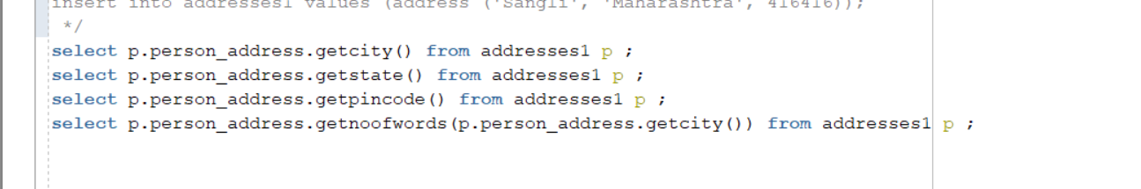

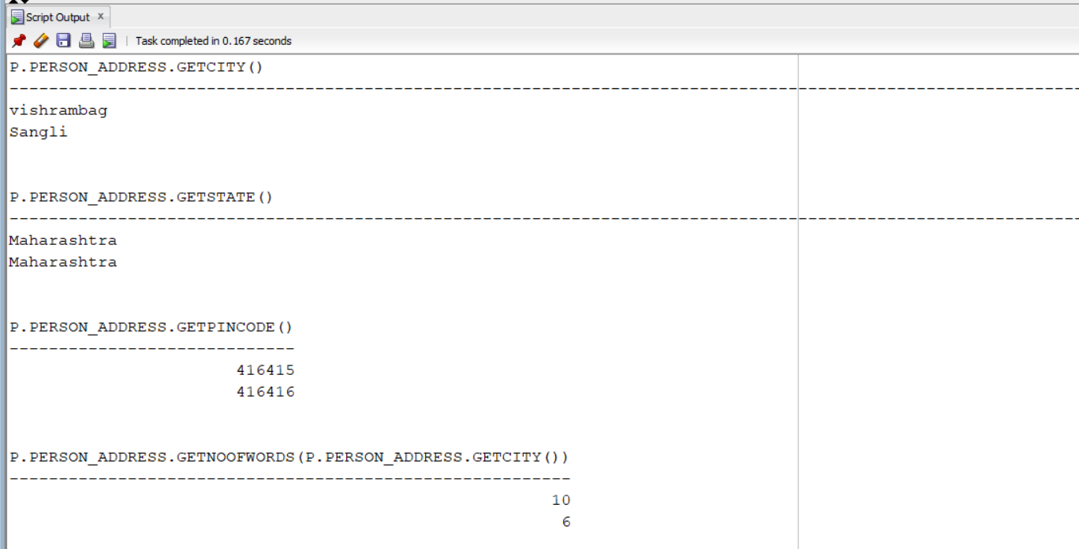

1. Create a user defined data type course_Type with 2 attributes course_id, description: i. Create an object table based on the type created. j. Insert rows into the table Demonstrate working with different data sets.

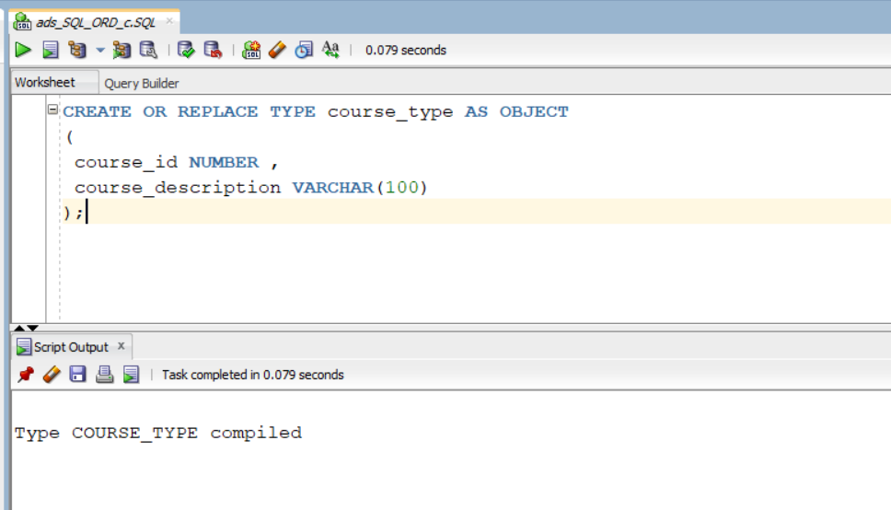

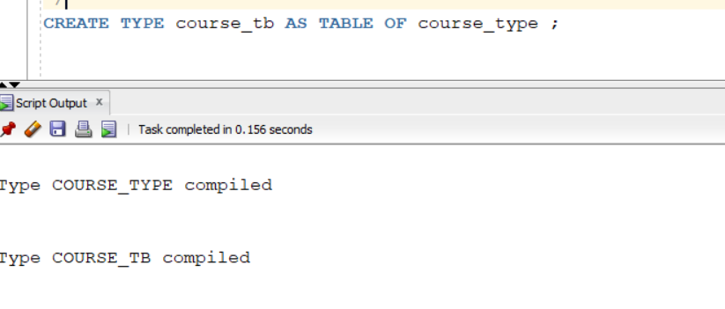

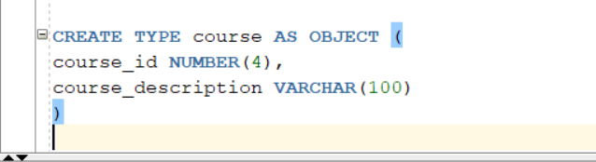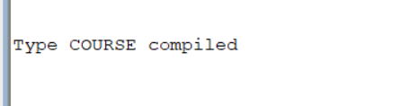

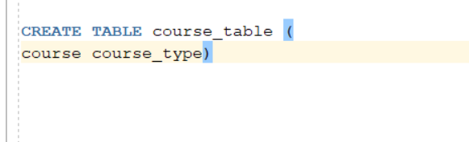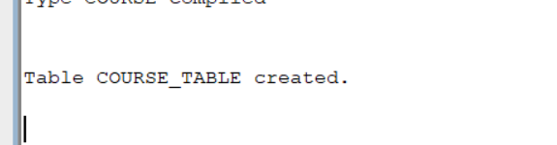

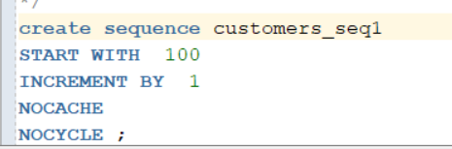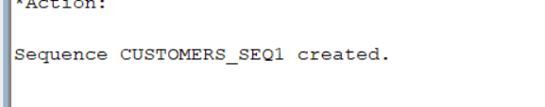

Inserting data :

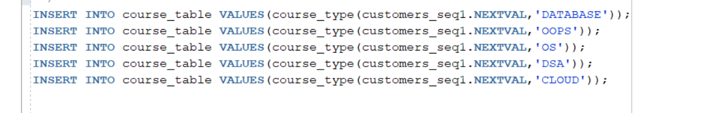

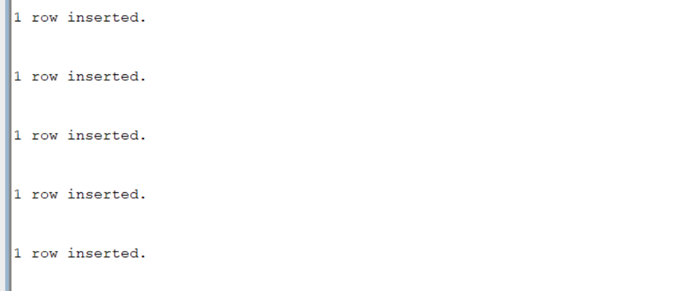

Query :

